**ForgetMeNot**

iPhone Application Design and Implementation - INB345 Project

Jack Chen, Bodaniel Jeanes, Anthony Mittaz

**Abstract**

This document covers the business case, market research, user interface design of ForgetMeNot, an iPhone application designed to help with memorizing of facts about other people.

Table of Contents

Introduction 3

Development Process 6

Technical Features 10

References 13

# Introduction

Humans are forgetful. This is a fact. We were not born with infallible memories. Ever since the introduction of the versatile pen and paper, we have written down things we would forget and we would refer to them later on. Technology has improved and so have our abilities to store information. From notebooks, to organisers, to computers, to the internet, to PDAs and mobile phones, we have gained the ability to organize and search for information more effectively. With the advent of search engines such as Google, we have easy access to more information than ever. However, there is a frontier on the information front that has not been made easily searchable yet.

Web applications like Facebook and OkCupid have attempted to make personal information such as interests, hobbies etc., searchable, but the lack of a rigid classification system and unintelligent ways of searching, as well as it not being a primary feature detracts from the experience.

Even if the information was made easily searchable and categorised, then the question is how to get to that information when you need it, and how to use the information effectively in real life situations.

This is the main problem ForgetMeNot plans to solve. It is a searchable and categorised database of factoids about people you know or may encounter. Data can be imported from existing sources like Facebook or LinkedIn, which are then categorised into different fact types. This information can now be searched and recalled anywhere, anytime.Business Case

As covered in the introduction, there are a scant few people in the world with photographic memory. The core problem with most information is that it is rarely there when you need it. With the advent of mobile internet and the introduction of more and more mobile devices that are capable of harnessing the internet, this is becoming less of an issue. People can now access the email, search the internet, check the weather, public transport times, etc from anywhere given they have an internet connection on their mobile, but there are a few things that mobile computing still does not cover. One of these is storage, classification, and retrieval of personal facts about people.

ForgetMeNot is the first application that puts storing and organising personal facts first and foremost, as opposed to a secondary function like Facebook has. A survey revealed that many people had issues with remembering names, but remembering personal facts like what school they went to and what bands they like was much tougher. There are many pre-existing ways to tackle this problem, mainly involving mnemonic devices that help you link names to faces, but there a scant few techniques that help you remember which of your work colleagues like a particular sports team.

For example, say you had to meet an important client to seal a contract, and you know that he has a daughter that likes to draw and her birthday is coming up. You buy a set of Staedtler markers and offhandedly present it to the client during the meeting. This piece of seemly innocuous bit of information might be critical to sealing the contract.

Or, let’s say that you are attending a high school reunion. You can use the quiz mode of ForgetMeNot and select people who you will run into there, and have it drill names to faces, what their hobbies are, etc so you can easily start conversations and build rapport, which effectively strengthens your relationship with that person.

# Development Process

Ever since the release of the original iPhone on June 29th, 2007 and the release of the updated and much anticipated iPhone 3G on July 11th, 2008, the iPhone has upset the predominately stable smartphone industry. Before the introduction of the iPhone, the market was dominated by heavyweight Nokia, followed by RIM and HTC, but this changed when Apple announced the App Store alongside the iPhone 3G’s release.

The App Store is a centralised application download service that allows both iPhones and iPod Touches to easily download both free and paid applications extremely easily. This allowed developers to focus more on developing the application instead of worrying about distribution methods, advertising and DRM since the App Store provides all this. Mobile application development on other platforms had been stagnating due to the difficulties in reaching the target user audience, as small application development companies did not have the budget to advertise their application.

The success of the App Store is measured in the quality and quantity of the applications, as well as how many users are downloading applications. April 23rd, 2009 marked the date where the App Store hosts just over 35,000 applications and one-billionth application had been downloaded from the App Store.

However, the App Store is nothing new. Nokia had a similar concept on Nokia S40 and S60 phones called Download!, but due to the scant few applications that was on there, as well as the horrible navigational system and lack of marketing, this was never used.

The combination of an always-on internet connection, a powerful multi-touch screen, an internal accelerometer and GPS allows for many new and innovative applications to be built.

Since all three team members in our group own an iPhone, combined with the technical ability, we strove out to create an application that would be useful to us and to a significant portion of the market, as well as being innovative.

And so we thought: with access to almost every stretch of human information in the palm of our hands, whenever, wherever, what was still missing?

Everyone has been in an awkward social situation when you cannot remember basic details about someone you are talking to. It could be their name, their career, their hobbies, favourite bands, sports teams or even relationship status. In a world that provides information ubiquitously and effortlessly, why are these facts not part of that available data?

We decided to develop an application for the iPhone that would allow mobile users to input the titbits of random facts about associates into a central place so that they could refer to them later. The idea was to allow users to create groups of contextual and relevant information that would make it intuitive to retrieve the information, either in an attempt to quiz yourself into remembering them, or to simply jog your memory during a meeting or conversation.

We started the development process by meeting over the course of the first few weeks and planning out features and mocking out the interface and interactions. We then iteratively chose features to work on based on their usefulness and uniqueness, with the ultimate plan of finishing the semester with a product worthy of a real release to the world.

The idea drew in our passion and this pushed us to spend great attention on small details such as the quality and interface of the application, as well as making sure existing features were rock solid before building new ones.

The images below show how the mock-ups were turned into real features:

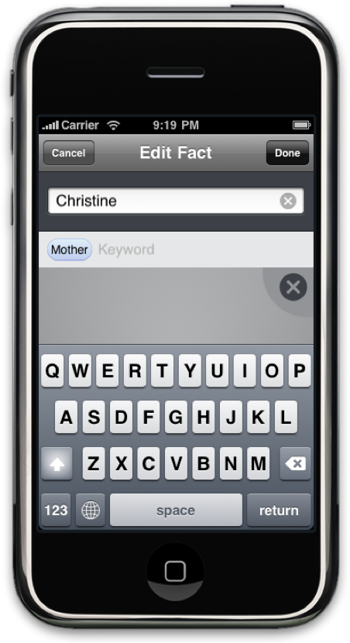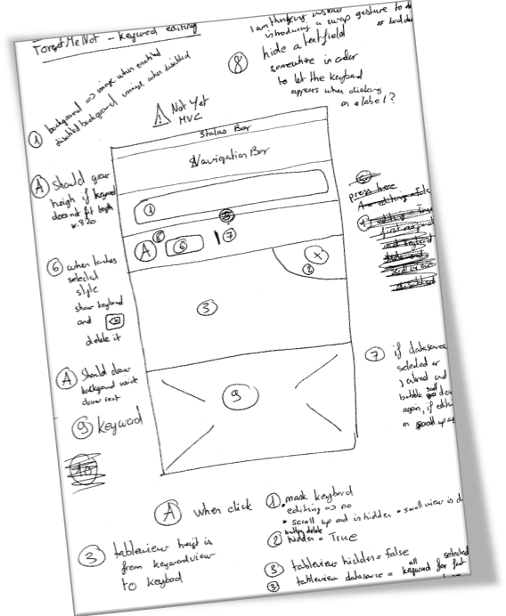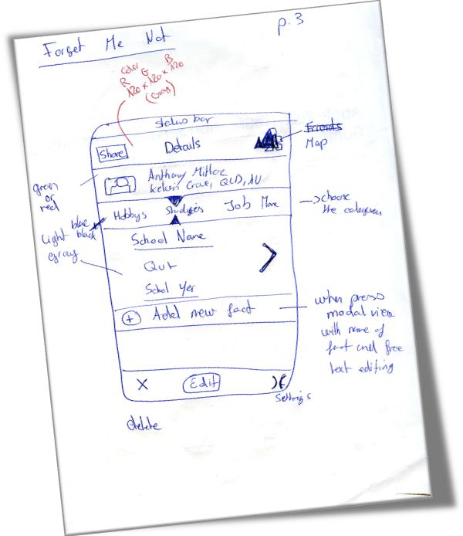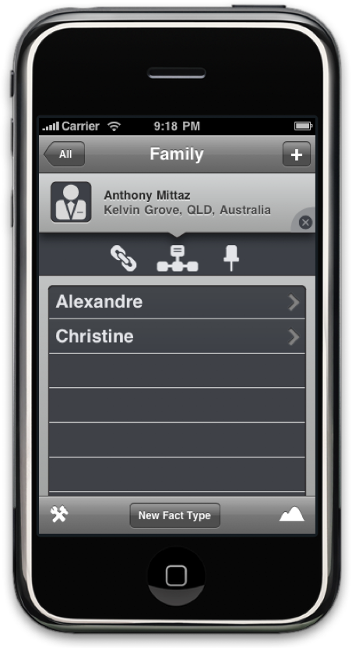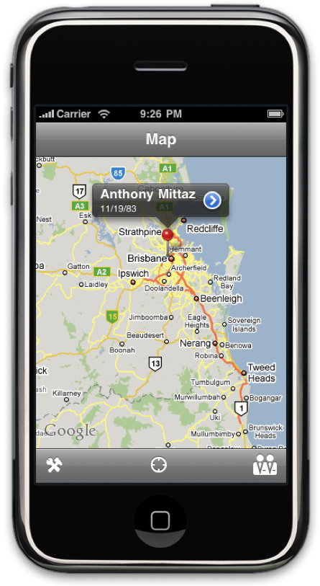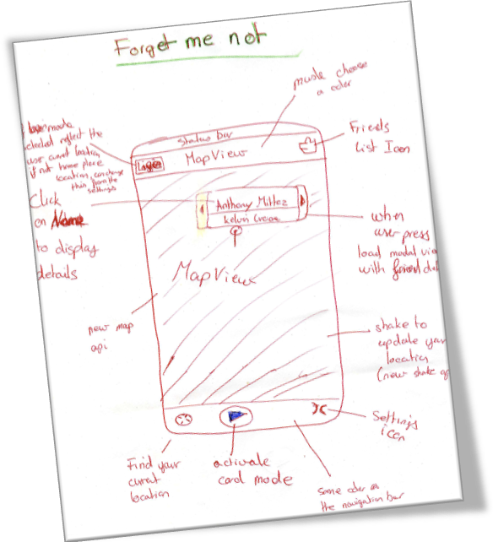

# Technical Features

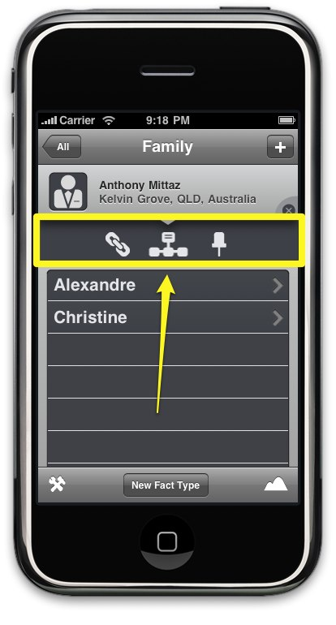A few noteable technical aspects of ForgetMeNot include the table view slider (pictured below), which is not a standard iPhone UI widget. Anthony Mittaz created it from scratch for ForgetMeNot.

The other widget that was created from scratch is the keyword widget shown below. It is based off the keyword interface seen in Mail and the Messaging 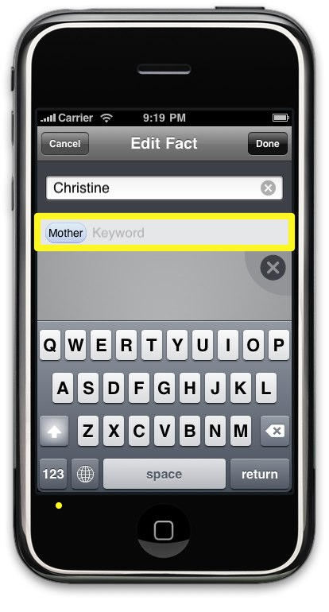app on the iPhone.

Other notable technical achievements include using the iPhone 3.0 SDK, which includes many improvements compared to the current generation.Conclusion

ForgetMeNot is an innovative application that will lead the field in people information gathering, organisation, retrieval and memorisation. The application will be released on the App Store when the iPhone 3.0 update comes around. The information gathered using ForgetMeNot might lead to a brand new market that allows people with a common set of interests to discover each other, as well as enabling marketers to target their advertisements much more effectively, increasing their return on investment.

ForgetMeNot has the potential to build the base for a new social networking platform that can rival Facebook, but it needs funding and more thought.

# References

App Store. (2009, May 25). In *Wikipedia, The Free Encyclopedia*. Retrieved 17:58, May 25, 2009, from <http://en.wikipedia.org/w/index.php?title=App_Store&oldid=292411957>

Gartner Says Worldwide Mobile Phone Sales Declined 8.6 Per Cent and Smartphones Grew 12.7 Per Cent in First Quarter of 2009.(2009, May 25). In *Wikipedia, The Free Encyclopedia*. Retrieved 15:23, May 26, 2009, from <http://www.gartner.com/it/page.jsp?id=985912>